Nama : Dimas Aldi Kartika

NIM : 21120117130057

Kelas : A

**Tugas JSF 2**

**Rekayasa Perangkat Lunak Berbasis Komponen**

*Screenshoot* tutorial JSF 2: Ajax Support

* **Random Number With/Without Ajax**

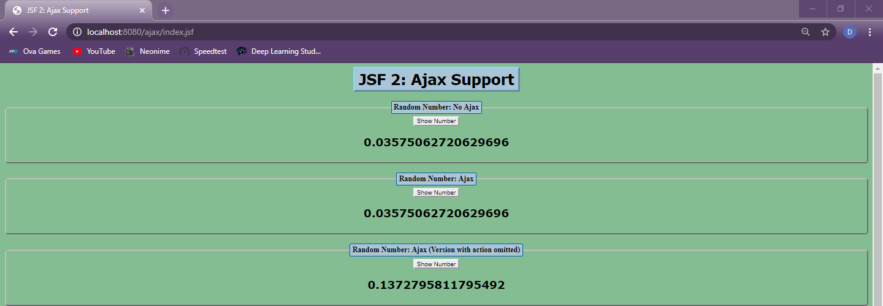

* **Random Number With ID, Bank Customer Lookup, Population Lookup**



* **Temperature Converter, Bank Customer Lookup With onevent**

